

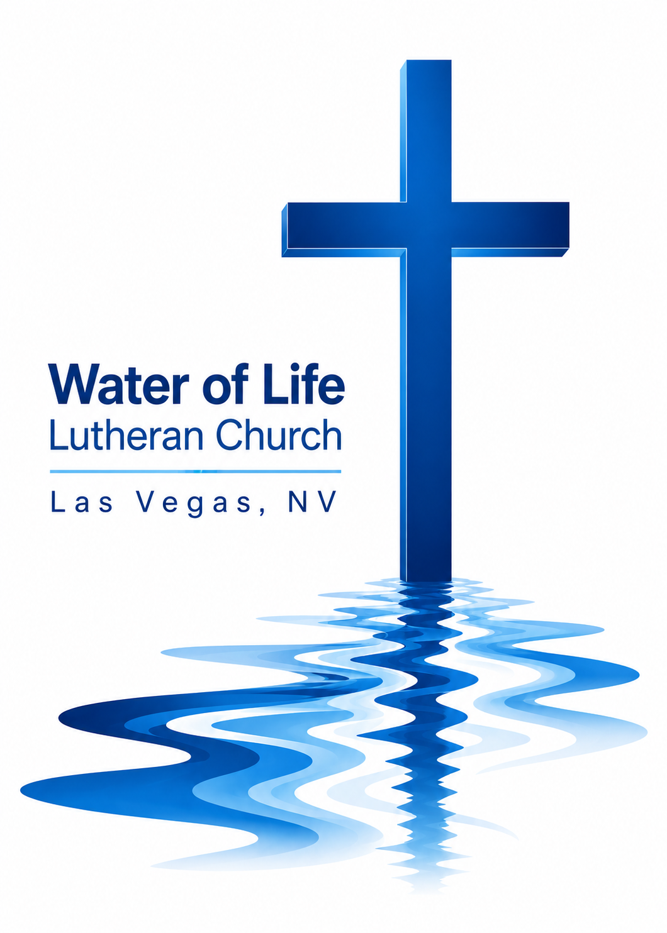

August 9, 2026
Eleventh Sunday after Pentecost

WELCOME TO WORSHIP
Welcome and thank you for joining us for worship today! In our service we gather before our almighty and saving God to offer him our worship and praise. We also assemble to hear God’s holy and powerful word and celebrate his life-giving sacraments. Through these means, God strengthens our faith and walks us ever closer to our eternal home with him.

The order of service we follow is printed out in this worship folder. You’ll notice that the service is a dialogue between God and us, his people. The pastor speaks to God along with the congregation and also speaks the Word of God to the people.

Please fill out Connect Card. Place it in the plate when the offering is collected.

Pastor David Bitter
Email: pastor@wateroflifelasvegas.org
Office phone number: (702) 253-7087
Cell phone Number: (414) 477-2321

Stacy Bitter – WoL Preschool Director
Email: director@wateroflifeschool.org
Office phone number: (702) 253-7020

Church Website: wateroflifelasvegas.org

Church Facebook page: Water of Life Lutheran Church Las Vegas


Scan code to give online
Praise the One Who Breaks the Darkness
Praise the one who breaks the darkness
with a liberating light;
praise the one who frees the pris’ners,
turning blindness into sight.
Praise the one who preached the gospel,
healing ev’ry dread disease,
calming storms and feeding thousands
with the Father’s word of peace.

Praise the one who blessed the children
with a strong, yet gentle, word;
praise the one who drove out demons
with the piercing, two-edged sword.
Praise the one who brings cool water
to the desert’s burning sand;
from this well comes living water,
quenching thirst in ev’ry land.

Let us praise the Word incarnate,
Christ, who suffered in our place;
Jesus died and rose victorious
that we may know God by grace.
Let us sing for joy and gladness,
seeing what our God has done;
let us praise the true Redeemer,
praise the one who makes us one.

Invocation

In the name of the Father and of the Son and of the Holy Spirit.
Amen.
Confession
If we claim to be without sin, we deceive ourselves and the truth is not in us.
If we confess our sins, God is faithful and just
and will forgive us our sins and purify us from all unrighteousness.
Let us confess our sins to the Lord.
Holy God, gracious Father,
I am sinful by nature and have sinned against you in my thoughts, words, and actions. I have not loved you with my whole heart; I have not loved others as I should. I deserve your punishment both now and forever.
But Jesus, my Savior, paid for my sins with his innocent suffering and death. Trusting in him, I pray: God, have mercy on me, a sinner.

Silence for meditation and reflection

Absolution

Our gracious Father in heaven has been merciful to us. He sent his only Son, Jesus Christ, who gave his life as the atoning sacrifice for the sins of the whole world. Therefore, as a called servant of Christ and by his authority, I forgive you all your sins in the name of the Father and of the T Son and of the Holy Spirit.
Amen.
Lord, Have Mercy
In peace let us pray to the Lord.
Lord, have mercy.

For the peace from above and for our salvation, let us pray to the Lord.
Lord, have mercy.

For the peace of the whole world, for the well-being of the Church of God, and for the unity of all, let us pray to the Lord.
Lord, have mercy.

For this holy house and for all who offer here their worship and praise, let us pray to the Lord.
Lord, have mercy.

Help, save, comfort, and defend us, gracious Lord.
Amen.

The Word
Prayer of the Day
Almighty and everlasting God, you are always more ready to hear than we to pray and willing to give far more than we either desire or deserve. Pour upon us the abundance of your mercy, forgiving us those things of which our conscience is afraid, and giving us those good things for which we are not worthy to ask, except through the merits and mediation of your Son, Jesus Christ our Lord, who lives and reigns with you and the Holy Spirit, one God, now and forever.
Amen.​

First Reading 1 Kings 17:1–6
1Now Elijah the Tishbite, from Tishbe in Gilead, said to Ahab, “As the Lord, the God of Israel, lives, whom I serve, there will be neither dew nor rain in the next few years except at my word.”
2Then the word of the Lord came to Elijah: 3“Leave here, turn eastward and hide in the Kerith Ravine, east of the Jordan. 4You will drink from the brook, and I have directed the ravens to supply you with food there.”
5So he did what the Lord had told him. He went to the Kerith Ravine, east of the Jordan, and stayed there. 6The ravens brought him bread and meat in the morning and bread and meat in the evening, and he drank from the brook.

The Word of the Lord.
Thanks be to God.

Second Reading Ephesians 1:3–10
3Praise be to the God and Father of our Lord Jesus Christ, who has blessed us in the heavenly realms with every spiritual blessing in Christ. 4For he chose us in him before the creation of the world to be holy and blameless in his sight. In love 5he predestined us for adoption to sonship through Jesus Christ, in accordance with his pleasure and will— 6to the praise of his glorious grace, which he has freely given us in the One he loves.
7In him we have redemption through his blood, the forgiveness of sins, in accordance with the riches of God’s grace 8that he lavished on us. With all wisdom and understanding, 9he made known to us the mystery of his will according to his good pleasure, which he purposed in Christ, 10to be put into effect when the times reach their fulfillment—to bring unity to all things in heaven and on earth under Christ.

The Word of the Lord.
Thanks be to God.
Gospel Acclamation Hebrews 11:1
Alleluia. He who did not spare his own Son, but gave him up for us all—
how will he not also, along with him, graciously give us all things? ​Alleluia.

Gospel Matthew 14:13–21
13When Jesus heard what had happened, he withdrew by boat privately to a solitary place. Hearing of this, the crowds followed him on foot from the towns. 14When Jesus landed and saw a large crowd, he had compassion on them and healed their sick.
15As evening approached, the disciples came to him and said, “This is a remote place, and it’s already getting late. Send the crowds away, so they can go to the villages and buy themselves some food.”
16Jesus replied, “They do not need to go away. You give them something to eat.”
17“We have here only five loaves of bread and two fish,” they answered.
18“Bring them here to me,” he said. 19And he directed the people to sit down on the grass. Taking the five loaves and the two fish and looking up to heaven, he gave thanks and broke the loaves. Then he gave them to the disciples, and the disciples gave them to the people. 20They all ate and were satisfied, and the disciples picked up twelve basketfuls of broken pieces that were left over. 21The number of those who ate was about five thousand men, besides women and children.

The Gospel of the Lord.
Praise be to you, O Christ!

Apostles' Creed
I believe in God, the Father Almighty,
maker of heaven and earth.

I believe in Jesus Christ, his only Son, our Lord,
who was conceived by the Holy Spirit,
born of the Virgin Mary,
suffered under Pontius Pilate,
was crucified, died, and was buried.
He descended into hell.
The third day he rose again from the dead.
He ascended into heaven
and is seated at the right hand of God the Father Almighty.
From there he will come to judge the living and the dead.

I believe in the Holy Spirit,
the holy Christian Church,
the communion of saints,
the forgiveness of sins,
the resurrection of the body,
and the life everlasting. Amen.

Across the Lands
You’re the Word of God the Father
from before the world began.
Ev’ry star and ev’ry planet
has been fashioned by your hand.
All creation holds together
by the power of your voice.
Let the skies declare your glory,
let the land and seas rejoice! (Refrain)

Refrain You’re the author of creation,
you’re the Lord of ev’ry man,
and your cry of love rings out across the lands.

Yet you left the gaze of angels,
came to seek and save the lost,
and exchanged the joy of heaven
for the anguish of a cross.
With a prayer you fed the hungry,
with a word you calmed the sea,
yet how silently you suffered
that the guilty may go free! (Refrain)

With a shout you rose victorious,
wresting vict’ry from the grave,
and ascended into heaven,
leading captives in your way.
Now you stand before the Father,
interceding for your own;
from each tribe and tongue and nation
you are leading sinners home! (Refrain)
Sermon

Offering

Please place your connect card in the offering plate at this time.

Forgot your checkbook and don’t have cash but would still
like to give a gift
to help spread God’s Word?

Scan the QR code and you’ll be able to securely set up
anything you’d like to give in a number of different ways.

Or find the “give” button on the upper right side of our
website.
www.wateroflifelasvegas.org
Prayer of the Church
Eternal Lord, give us peace as we ponder the good news that you forgive our sins in Christ. Lead us to see clearly the path you have laid out for us.
Work in us so that we believe and live the Word we have heard today.

Provide courage and compassion to all who preach and teach your Word. Fill them with a love like yours as they proclaim your grace to us and all people.
Move us to love all ministers of the Word wherever they serve.

Guard and guide the families of our congregation. Lead husbands and wives to love each other with commitment, respect, and patience. Help parents to grasp the eternal value of keeping their children close to Jesus all their lives. Grant joy to those who are single, and make them a blessing to others.
Protect us from the temptations that surround us; give us pure hearts and minds.
Provide wisdom and insight to those who make laws and set policies. Give us respect for those who protect us from crime. Lead us to value the rights of our fellow citizens and to defend those who cannot defend themselves.
Bless our land with peace and prosperity so that the gospel may be proclaimed to all.

Give us passion to share the story of your love with our family and friends. Overcome unbelief, and open the hearts of people everywhere to believe the good news that Jesus has forgiven their sins and opened the gates of heaven.
Fill us with joy over every sinner who repents and comes to trust in you.

Extend your healing power to those who are sick and suffering in body or mind. [Pour out your special blessing on . . . here name the person and the cause of the petition.] Give patience and compassion to all who care for the sick and dying.
Lift the eyes of the distressed to your love in Christ.

Hear us, Lord, as we pray in silence.

Silent prayer

Gracious God, you govern and direct all things and you love all people. Hear our prayers, spoken and silent, and answer them in your wisdom and grace.
In Jesus’ name we pray. Amen.

Lord’s Prayer

Our Father, who art in heaven,
hallowed be thy name, thy kingdom come,
thy will be done on earth as it is in heaven.
Give us this day our daily bread.
And forgive us our trespasses,
as we forgive those who trespass against us.
And lead us not into temptation, but deliver us from evil.
For thine is the kingdom and the power and the glory forever and ever. Amen.

Blessing
Brothers and sisters, go in peace. Live in harmony with one another, and serve the Lord with gladness.
The Lord bless you and keep you.
The Lord make his face shine on you and be gracious to you.
The Lord look on you with favor and ✝ give you peace.
Amen.
Day by Day
Day by day, your mercies, Lord, attend me,
bringing comfort to my anxious soul.
Day by day, the blessings, Lord, you send me
draw me nearer to my heav’nly goal.
Love divine, beyond all mortal measure,
brings to naught the burdens of my quest;
Savior, lead me to the home I treasure,
where at last I’ll find eternal rest.

Day by day, I know you will provide me
strength to serve and wisdom to obey;
I will seek your loving will to guide me
o’er the paths I struggle day by day.
I will fear no evil of the morrow,
I will trust in your enduring grace.
Savior, help me bear life’s pain and sorrow
till in glory I behold your face.

Oh, what joy to know that you are near me
when my burdens grow too great to bear;
oh, what joy to know that you will hear me
when I come, O Lord, to you in prayer.
Day by day, no matter what betide me,
you will hold me ever in your hand.
Savior, with your presence here to guide me,
I will reach at last the promised land.

Announcements
Bible Study Wednesday night at 7:00 pm!​
4608 Wonderful St.​ ************************************************

Visitation and Burial Service Information for Cynthia Hutchins.
Friday, August 14 at
Palms Northwest Mortuary 6701 N Jones Blvd Las Vegas, NV 89131
Visitation hours will be from 10:00am -11:45am
Graveside service will begin at 12:00pm (Noon)

**********************************************************************
Thank offerings given on August 2, 2026, in total, were $ 1,779.10
If you would like to set up online offerings please visit
secure.myvanco.com/LZ24S/home
This is the secure site to sign up for offerings made to Water of Life.
Offering envelopes are available.
If you would like a box, please see Jennifer Santos.
Thank you for supporting the ministry work at Water of Life.

Preschool Bible Project – Can You Help?
Water of Life Preschool would like to provide a children's Bible to every preschool family this year. Our goal is to purchase 30 Bibles, with each Bible costing $15.
If you would like to help make this possible, please make your check payable to
Water of Life Church or use the QR code below to donate.
Thank you for helping us share God's Word with our preschool families!


