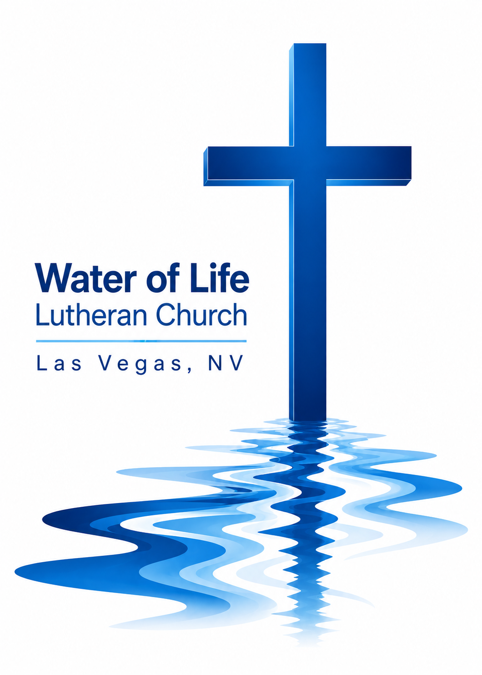

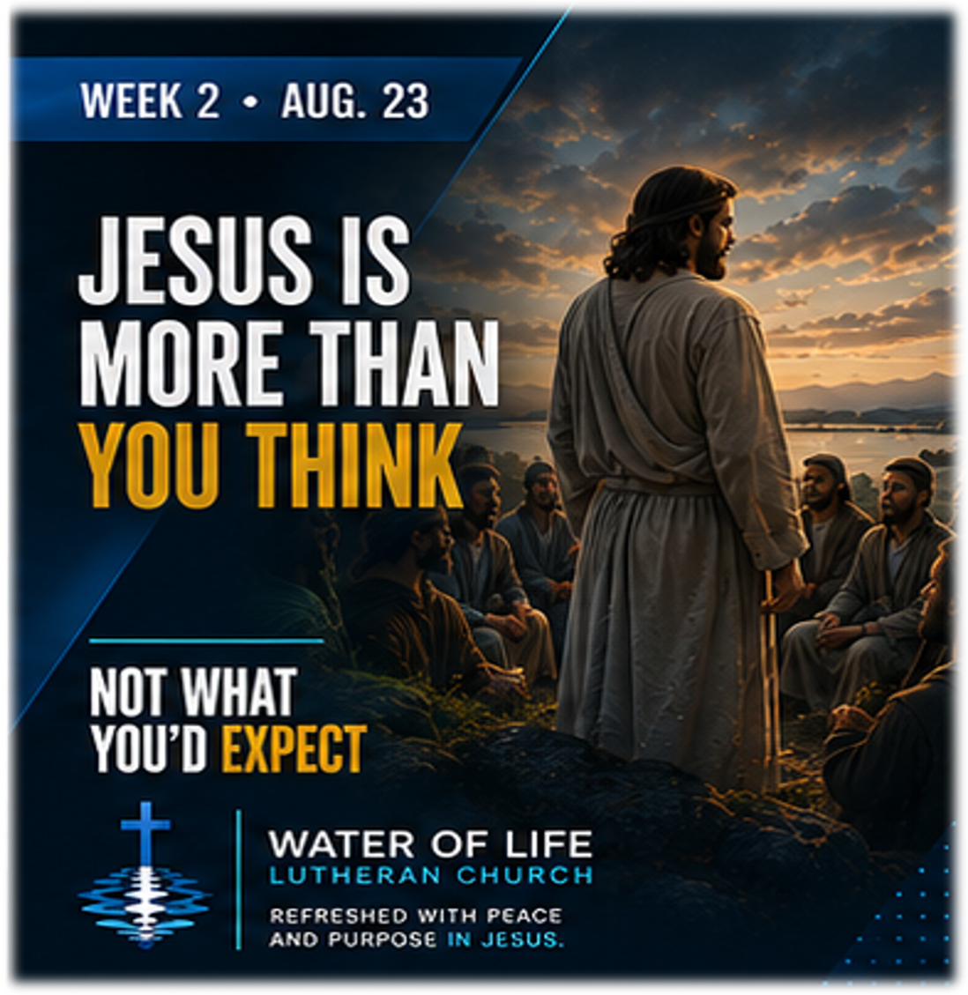

August 23, 2026
Thirteenth Sunday after Pentecost

WELCOME TO WORSHIP
Welcome and thank you for joining us for worship today! In our service we gather before our almighty and saving God to offer him our worship and praise. We also assemble to hear God’s holy and powerful word and celebrate his life-giving sacraments. Through these means, God strengthens our faith and walks us ever closer to our eternal home with him.

The order of service we follow is printed out in this worship folder. You’ll notice that the service is a dialogue between God and us, his people. The pastor speaks to God along with the congregation and also speaks the Word of God to the people.

Please fill out Connect Card. Place it in the plate when the offering is collected.

Pastor David Bitter
Email: pastor@wateroflifelasvegas.org
Office phone number: (702) 253-7087
Cell phone Number: (414) 477-2321

Stacy Bitter – WoL Preschool Director
Email: director@wateroflifeschool.org
Office phone number: (702) 253-7020

Church Website: wateroflifelasvegas.org

Church Facebook page: Water of Life Lutheran Church Las Vegas


Scan code to give online
All Praise to Him
All praise to him, the God of light
who formed the mountains by his might.
All praise to him who names the stars
that sing his fame in skies afar.
All praise to him who reigns in love,
who guides the galaxies above,
yet bends to hear our ev’ry prayer
with sov’reign pow’r and tender care.

All praise to him whose love is seen
in Christ the Son, the servant King,
who left behind his glorious throne
to pay the ransom for his own.
All praise to him who humbly came
to bear our sorrow, sin, and shame,
who lived to die, who died to rise,
the all-sufficient sacrifice.

All praise to him whose pow’r imparts
the love of God within our hearts,
the Spirit of all truth and peace,
the fount of joy and holiness.
To Father, Son, and Spirit now
our souls we lift, our wills we bow;
to you, the triune God, we raise
with loving hearts our song of praise.

Invocation

In the name of the Father and of the Son and of the Holy Spirit.
Amen.

Opening Sentences
People have many different opinions about Jesus. Some call him a teacher. Some call him a prophet. Some admire him as a good man. But Jesus is more than many expect. He is the eternal Son of God who came into this world to save sinners. Everyone who calls on the name of the Lord will be saved. (Romans 10:13)
Confession
God has revealed himself to us as compassionate and gracious, slow to anger, and abounding in love and faithfulness. Yet we have not loved him with our whole heart or trusted him above all things. We have trusted our own wisdom, followed the thinking of the world, and failed to live as his faithful people. Therefore, let us confess our sins before our gracious God.
Merciful Father, I confess that I have sinned against you in my thoughts, words, and actions. I have not loved you with my whole heart. I have not trusted you as I should. I have failed to speak and live as your faithful child. Forgive me for the sake of Jesus Christ. Have mercy on me, renew me, and strengthen me to live according to your will.

Silence for meditation and reflection

Absolution
Hear the good news of who Jesus truly is. He is the Messiah, the Son of the living God. He came into this world for sinners. He lived in perfect obedience in our place, carried our sins to the cross, and rose again in victory over sin and death.
Therefore, as a called servant of Christ, and by his authority, I forgive you all your sins in the name of the Father and of the Son ✝ and of the Holy Spirit.
Amen.

The Word
Prayer of the Day
Almighty God, whom to know is everlasting life, grant us to know your Son, Jesus, to be the way, the truth, and the life that we may boldly confess him to be the Christ and steadfastly walk in the way that leads to life eternal; through your Son, Jesus Christ our Lord, who lives and reigns with you and the Holy Spirit, one God, now and forever.
Amen.
First Reading Exodus 34:5–9
5Then the Lord came down in the cloud and stood there with him and proclaimed his name, the Lord. 6And he passed in front of Moses, proclaiming, “The Lord, the Lord, the compassionate and gracious God, slow to anger, abounding in love and faithfulness, 7maintaining love to thousands, and forgiving wickedness, rebellion and sin. Yet he does not leave the guilty unpunished; he punishes the children and their children for the sin of the parents to the third and fourth generation.”
8Moses bowed to the ground at once and worshiped. 9“Lord,” he said, “if I have found favor in your eyes, then let the Lord go with us. Although this is a stiff-necked people, forgive our wickedness and our sin, and take us as your inheritance.”

The Word of the Lord.
Thanks be to God.
Second Reading Romans 10:5–13
5Moses writes this about the righteousness that is by the law: “The person who does these things will live by them.” 6But the righteousness that is by faith says: “Do not say in your heart, ‘Who will ascend into heaven?’ ” (that is, to bring Christ down) 7“or ‘Who will descend into the deep?’ ” (that is, to bring Christ up from the dead). 8But what does it say? “The word is near you; it is in your mouth and in your heart,” that is, the message concerning faith that we proclaim: 9If you declare with your mouth, “Jesus is Lord,” and believe in your heart that God raised him from the dead, you will be saved.
10For it is with your heart that you believe and are justified, and it is with your mouth that you profess your faith and are saved.
11As Scripture says, “Anyone who believes in him will never be put to shame.” 12For there is no difference between Jew and Gentile—the same Lord is Lord of all and richly blesses all who call on him, 13for, “Everyone who calls on the name of the Lord will be saved.”

The Word of the Lord.
Thanks be to God.

Gospel Acclamation John 6:68
Alleluia. Lord, to whom shall we go? You have the words of eternal life. Alleluia.
Gospel Matthew 16:13–20
13When Jesus came to the region of Caesarea Philippi, he asked his disciples, “Who do people say the Son of Man is?”
14They replied, “Some say John the Baptist; others say Elijah; and still others, Jeremiah or one of the prophets.”
15“But what about you?” he asked. “Who do you say I am?”
16Simon Peter answered, “You are the Messiah, the Son of the living God.”
17Jesus replied, “Blessed are you, Simon son of Jonah, for this was not revealed to you by flesh and blood, but by my Father in heaven. 18And I tell you that you are Peter, and on this rock I will build my church, and the gates of Hades will not overcome it. 19I will give you the keys of the kingdom of heaven; whatever you bind on earth will be bound in heaven, and whatever you loose on earth will be loosed in heaven.” 20Then he ordered his disciples not to tell anyone that he was the Messiah.

The Gospel of the Lord.
Praise be to you, O Christ!
Apostles’ Creed
I believe in God, the Father Almighty,
maker of heaven and earth.

I believe in Jesus Christ, his only Son, our Lord,
who was conceived by the Holy Spirit, born of the Virgin Mary,
suffered under Pontius Pilate, was crucified, died, and was buried.
He descended into hell. The third day he rose again from the dead.
He ascended into heaven and is seated at the right hand of God the
Father Almighty. From there he will come to judge the living and the
dead.

I believe in the Holy Spirit,
the holy Christian Church, the communion of saints, the forgiveness of sins, the resurrection of the body, and the life everlasting. Amen.
Christ Our Hope in Life and Death
What is our hope in life and death?
Christ alone, Christ alone
What is our only confidence?
That our souls to Him belong
Who holds our days within His hand?
What comes, apart from His command?
And what will keep us 'til the end?
The love of Christ, in which we stand
O sing hallelujah!
Our hope springs eternal
O sing hallelujah!
Now and ever we confess
Christ our hope in life and death
What truth can calm the troubled soul?
God is good, our God is good
Where is His grace and goodness known?
In our great Redeemer's blood
Who holds our faith when fears arise?
Who stands above the stormy trial?
Who sends the waves that bring us nigh
Unto the shore, the rock of Christ?
O sing hallelujah!
Our hope springs eternal
O sing hallelujah!
Now and ever we confess
Christ our hope in life and death
O sing hallelujah!
O sing hallelujah!
Unto the grave, what shall we sing?
"Christ, He lives; Christ, He lives!"
And what reward will heaven bring?
Everlasting life with Him
There we will rise to meet the Lord
Then sin and death will be destroyed
And we will feast in endless joy
When Christ is ours forevermore
O sing hallelujah!
Our hope springs eternal
O sing hallelujah!
Now and ever we confess
Christ our hope in life and death
Now and ever we confess
Christ our hope in life and death

Sermon

Offering

Please place your connect card in the offering plate at this time.

Forgot your checkbook and don’t have cash but would still
like to give a gift
to help spread God’s Word?

Scan the QR code and you’ll be able to securely set up
anything you’d like to give in a number of different ways.

Or find the “give” button on the upper right side of our
website.
www.wateroflifelasvegas.org
Prayer of the Church
Lord God, heavenly Father, we praise you for revealing yourself to us in your Word. The world offers countless opinions about Jesus, but you have shown us the truth: he is the Messiah, the Son of the living God, our Savior from sin and death.
Lord Jesus, strengthen us to know you and confess your name.

Gracious Father, preserve your holy Christian Church throughout the world. Bless pastors, teachers, missionaries, parents, and all who proclaim your Word. Keep your Church firmly built upon Christ and the saving truth of the gospel. Where your people face opposition or persecution for confessing Jesus, give them courage and strength.
Lord Jesus, strengthen us to know you and confess your name.

Bless this congregation and our preschool. Keep Christ at the center of everything we teach and do. Bless every visitor, every child, and every family who comes through our doors. May they encounter more than a church, friendly people, or helpful programs. Through your Word, bring them face-to-face with Jesus, their Savior.
Lord Jesus, strengthen us to know you and confess your name.

Give us courage to confess Jesus in our daily lives. When friends, neighbors, coworkers, and family members have questions about him, help us speak with gentleness and confidence. Keep us from being ashamed of his name or reducing him to merely a teacher or example. Give us opportunities to tell others that Jesus is the Savior they need.
Lord Jesus, strengthen us to know you and confess your name.

We pray for those who are sick, grieving, lonely, anxious, weary, or burdened by the cares of this life. Remind them that Jesus is not distant from their suffering. He is the compassionate and gracious Lord who has conquered sin and death and promises never to leave his people.
Lord Jesus, strengthen us to know you and confess your name.

Guide the leaders of our nation, our state, and our community. Give them wisdom to promote justice, restrain evil, protect the vulnerable, and serve for the good of all. Bless those who serve our communities as police officers, firefighters, healthcare workers, teachers, and members of the armed forces.
Lord Jesus, strengthen us to know you and confess your name.
Heavenly Father, when our sins accuse us and we wonder whether we have done enough to deserve your love, turn our eyes away from ourselves and back to Christ. Remind us that salvation does not depend upon what we accomplish for you but upon what Jesus has accomplished for us. Keep your promise before us: everyone who calls on the name of the Lord will be saved.
Lord Jesus, strengthen us to know you and confess your name.

Keep us steadfast in this confession throughout our lives: Jesus is the Messiah, the Son of the living God. And when our earthly lives come to an end, bring us safely into the eternal kingdom he has won for us.
Lord Jesus, strengthen us to know you and confess your name.

Into your hands, O Lord, we commend ourselves and all for whom we pray, trusting in your mercy through Jesus Christ, our Lord.
Amen.

Lord’s Prayer

Our Father, who art in heaven,
hallowed be thy name, thy kingdom come,
thy will be done on earth as it is in heaven.
Give us this day our daily bread.
And forgive us our trespasses,
as we forgive those who trespass against us.
And lead us not into temptation, but deliver us from evil.
For thine is the kingdom and the power and the glory forever and ever. Amen.

Blessing
Brothers and sisters, go in peace. Live in harmony with one another, and serve the Lord with gladness.
The Lord bless you and keep you.
The Lord make his face shine on you and be gracious to you.
The Lord look on you with favor and ✝ give you peace.
Amen.
10,000 Reasons
Refrain Bless the Lord, O my soul, O my soul
worship his holy name.
Sing like never before, O my soul;
I’ll worship your holy name.

The sun comes up, it’s a new day dawning;
it’s time to sing your song again.
Whatever may pass, and whatever lies before me,
let me be singing when the evening comes. (Refrain)

You’re rich in love, and you’re slow to anger.
Your name is great, and your heart is kind.
For all your goodness, I will keep on singing—
ten thousand reasons for my heart to find. (Refrain)

And on that day when my strength is failing,
the end draws near, and my time has come;
still my soul will sing your praise unending—
ten thousand years and then forevermore. (Refrain)

Announcements

Bible Study Wednesday night at 7:00 pm!​
4608 Wonderful St.​

**********************************************************************

Thank offerings given on August 16, 2026, in total, were $ 2,111.10
If you would like to set up online offerings please visit
secure.myvanco.com/LZ24S/home
This is the secure site to sign up for offerings made to Water of Life.
Offering envelopes are available.
If you would like a box, please see Jennifer Santos.
Thank you for supporting the ministry work at Water of Life.

