

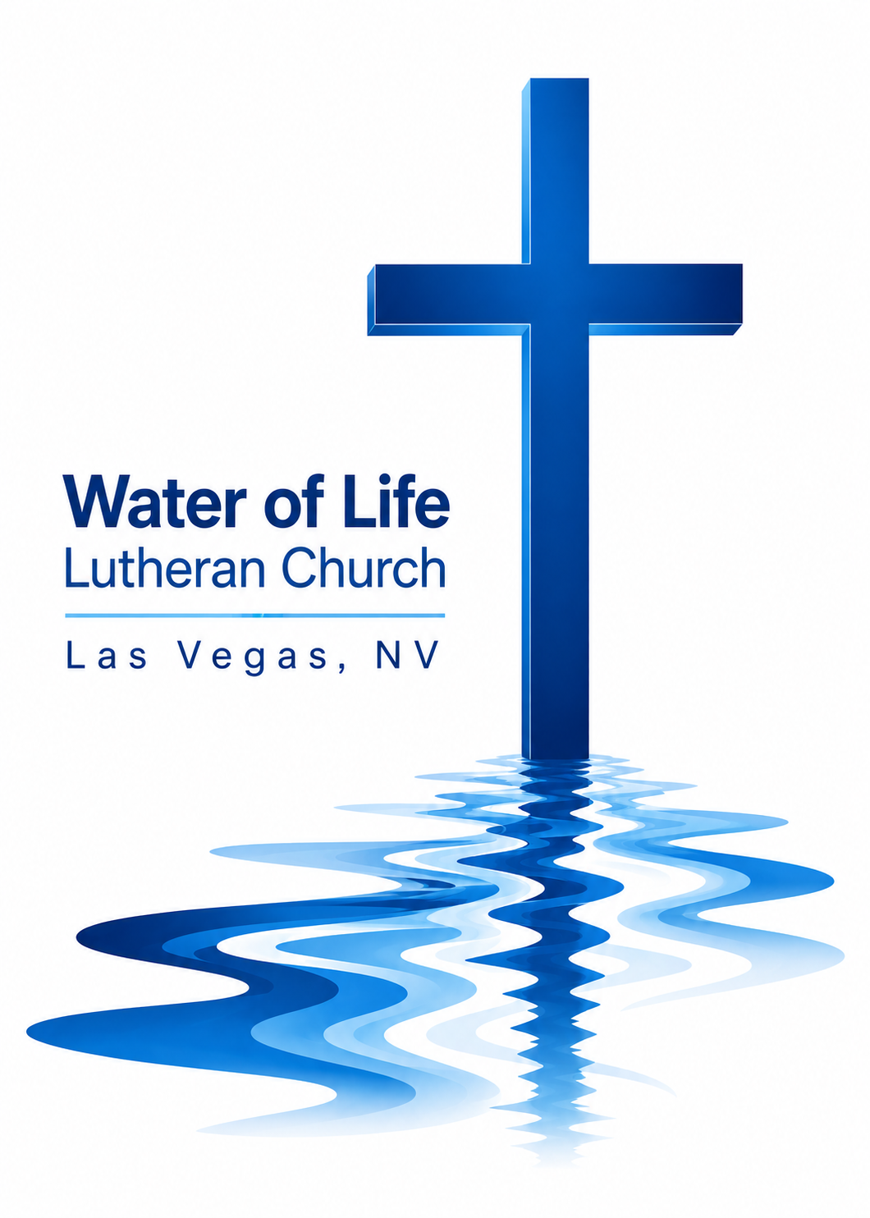

August 16, 2026
Twelfth Sunday after Pentecost

WELCOME TO WORSHIP
Welcome and thank you for joining us for worship today! In our service we gather before our almighty and saving God to offer him our worship and praise. We also assemble to hear God’s holy and powerful word and celebrate his life-giving sacraments. Through these means, God strengthens our faith and walks us ever closer to our eternal home with him.

The order of service we follow is printed out in this worship folder. You’ll notice that the service is a dialogue between God and us, his people. The pastor speaks to God along with the congregation and also speaks the Word of God to the people.

Please fill out Connect Card. Place it in the plate when the offering is collected.
Holy Communion
If you are a guest with us today, please see page 12 in today’s worship folder
(the Worship Notes) for information about our practice of Member Communion.

Pastor David Bitter
Email: pastor@wateroflifelasvegas.org
Office phone number: (702) 253-7087
Cell phone Number: (414) 477-2321

Stacy Bitter – WoL Preschool Director
Email: director@wateroflifeschool.org
Office phone number: (702) 253-7020

Church Website: wateroflifelasvegas.org

Church Facebook page: Water of Life Lutheran Church Las Vegas


Scan code to give online

O Lord, My Rock and My Redeemer
O Lord, my rock and my Redeemer,
greatest treasure of my longing soul,
my God, like you there is no other,
true delight is found in you alone.
Your grace, a well too deep to fathom,
your love exceeds the heavens’ reach,
your truth, a fount of perfect wisdom,
my highest good and my unending need.

O Lord, my rock and my Redeemer,
strong defender of my weary heart,
my sword to fight the cruel deceiver,
and my shield against his hateful darts,
my song when enemies surround me,
my hope when tides of sorrow rise,
my joy when trials are abounding,
your faithfulness, my refuge in the night.

O Lord, my rock and my Redeemer,
gracious Savior of my ruined life,
my guilt and cross laid on your shoulders,
in my place you suffered, bled, and died.
You rose, the grave and death are conquered;
you broke my bonds of sin and shame.
O Lord, my rock and my Redeemer,
may all my days bring glory to your name.

Invocation

In the name of the Father and of the Son and of the Holy Spirit.
Amen.
Confession
Blessed are they whose transgressions are forgiven, whose sins are covered.
Blessed are they whose sin the Lord does not count against them.
Let us confess our sins to the Lord.
Almighty and merciful Father,
we have strayed from your ways like lost sheep.
We have followed what we have devised and desired in our hearts.
We have offended you and sinned against your holy law.
We have done those things that we should not have done,
and we have not done those things that we should have done.
Have mercy on us, Lord!
Spare us, forgive us, and restore us,
according to your promises in Christ Jesus.

Silence for meditation and reflection

God, our merciful Father, has forgiven all our sins. He sent his Son, Jesus Christ, to be our Redeemer and Savior. Jesus paid the penalty for our guilt by his death on the cross and freed us from death by his resurrection from the grave. We have peace with God now and forever.
Amen.
Lord, Have Mercy
In peace let us pray to the Lord.
Lord, have mercy.

For the peace from above and for our salvation, let us pray to the Lord.
Lord, have mercy.

For the peace of the whole world, for the well-being of the Church of God, and for the unity of all, let us pray to the Lord.
Lord, have mercy.

For this holy house and for all who offer here their worship and praise, let us pray to the Lord.
Lord, have mercy.

Help, save, comfort, and defend us, gracious Lord.
Amen.

Prayer of the Day
Almighty and most merciful God, preserve us from all harm and danger that we, being ready in both body and soul, may cheerfully accomplish what you want done; through your Son, Jesus Christ our Lord, who lives and reigns with you and the Holy Spirit, one God, now and forever.
Amen.
First Reading 1 Kings 19:9–18
9There he went into a cave and spent the night.
And the word of the Lord came to him: “What are you doing here, Elijah?”
10He replied, “I have been very zealous for the Lord God Almighty. The Israelites have rejected your covenant, torn down your altars, and put your prophets to death with the sword. I am the only one left, and now they are trying to kill me too.”
11The Lord said, “Go out and stand on the mountain in the presence of the Lord, for the Lord is about to pass by.”
Then a great and powerful wind tore the mountains apart and shattered the rocks before the Lord, but the Lord was not in the wind. After the wind there was an earthquake, but the Lord was not in the earthquake. 12After the earthquake came a fire, but the Lord was not in the fire. And after the fire came a gentle whisper. 13When Elijah heard it, he pulled his cloak over his face and went out and stood at the mouth of the cave.
Then a voice said to him, “What are you doing here, Elijah?”
14He replied, “I have been very zealous for the Lord God Almighty. The Israelites have rejected your covenant, torn down your altars, and put your prophets to death with the sword. I am the only one left, and now they are trying to kill me too.”
15The Lord said to him, “Go back the way you came, and go to the Desert of Damascus. When you get there, anoint Hazael king over Aram. 16Also, anoint Jehu son of Nimshi king over Israel, and anoint Elisha son of Shaphat from Abel Meholah to succeed you as prophet. 17Jehu will put to death any who escape the sword of Hazael, and Elisha will put to death any who escape the sword of Jehu. 18Yet I reserve seven thousand in Israel—all whose knees have not bowed down to Baal and whose mouths have not kissed him.”

The Word of the Lord.
Thanks be to God.
Second Reading Romans 8:28–39
28And we know that in all things God works for the good of those who love him, who have been called according to his purpose. 29For those God foreknew he also predestined to be conformed to the image of his Son, that he might be the firstborn among many brothers and sisters. 30And those he predestined, he also called; those he called, he also justified; those he justified, he also glorified.
31What, then, shall we say in response to these things? If God is for us, who can be against us? 32He who did not spare his own Son, but gave him up for us all—how will he not also, along with him, graciously give us all things? 33Who will bring any charge against those whom God has chosen? It is God who justifies. 34Who then is the one who condemns? No one. Christ Jesus who died—more than that, who was raised to life—is at the right hand of God and is also interceding for us. 35Who shall separate us from the love of Christ? Shall trouble or hardship or persecution or famine or nakedness or danger or sword? 36As it is written:
“For your sake we face death all day long;
we are considered as sheep to be slaughtered.”
37No, in all these things we are more than conquerors through him who loved us. 38For I am convinced that neither death nor life, neither angels nor demons, neither the present nor the future, nor any powers, 39neither height nor depth, nor anything else in all creation, will be able to separate us from the love of God that is in Christ Jesus our Lord.

The Word of the Lord.
Thanks be to God.

Gospel Acclamation Hebrews 11:1
Alleluia! Now faith is confidence in what we hope for and assurance about what we do not see. Alleluia!

Gospel Matthew 14:22–33
22Immediately Jesus made the disciples get into the boat and go on ahead of him to the other side, while he dismissed the crowd. 23After he had dismissed them, he went up on a mountainside by himself to pray. Later that night, he was there alone, 24and the boat was already a considerable distance from land, buffeted by the waves because the wind was against it.
25Shortly before dawn Jesus went out to them, walking on the lake. 26When the disciples saw him walking on the lake, they were terrified. “It’s a ghost,” they said, and cried out in fear.
27But Jesus immediately said to them: “Take courage! It is I. Don’t be afraid.”
28“Lord, if it’s you,” Peter replied, “tell me to come to you on the water.”
29“Come,” he said.
Then Peter got down out of the boat, walked on the water and came toward Jesus. 30But when he saw the wind, he was afraid and, beginning to sink, cried out, “Lord, save me!”
31Immediately Jesus reached out his hand and caught him. “You of little faith,” he said, “why did you doubt?”
32And when they climbed into the boat, the wind died down. 33Then those who were in the boat worshiped him, saying, “Truly you are the Son of God.”

The Gospel of the Lord.
Praise be to you, O Christ!

Nicene Creed
We believe in one God, the Father, the Almighty,
maker of heaven and earth,
of all that is,
seen and unseen.

We believe in one Lord, Jesus Christ, the only Son of God,
eternally begotten of the Father,
God from God, Light from Light, true God from true God,
begotten, not made,
of one being with the Father.
Through him all things were made.
For us and for our salvation, he came down from heaven,
was incarnate of the Holy Spirit and the Virgin Mary,
and became truly human.
For our sake he was crucified under Pontius Pilate.
He suffered death and was buried.
On the third day he rose again in accordance with the Scriptures.
He ascended into heaven
and is seated at the right hand of the Father.
He will come again in glory to judge the living and the dead,
and his kingdom will have no end.

We believe in the Holy Spirit,
the Lord, the giver of life,
who proceeds from the Father and the Son,
who in unity with the Father and the Son
is worshiped and glorified,
who has spoken through the prophets.
We believe in one holy Christian and apostolic Church.
We acknowledge one baptism for the forgiveness of sins.
We look for the resurrection of the dead
and the life of the world to come. Amen.

Christ, the Sure and Steady Anchor
Christ, the sure and steady anchor
in the fury of the storm—
when the winds of doubt blow through me
and my sails have all been torn,
in the suff’ring, in the sorrow,
when my sinking hopes are few,
I will hold fast to the anchor;
it shall never be removed.

Christ, the sure and steady anchor
while the tempest rages on—
when temptation claims the battle
and it seems the night has won,
deeper still then goes the anchor,
though I justly stand accused;
I will hold fast to the anchor;
it shall never be removed.

Christ, the sure and steady anchor
through the floods of unbelief—
hopeless, somehow, O my soul now,
lift your eyes to Calvary.
This my ballast of assurance,
see his love forever proved;
I will hold fast to the anchor;
it shall never be removed.

Christ, the sure and steady anchor
as we face the wave of death—
when these trials give way to glory
and we draw our final breath,
we will cross that great horizon,
clouds behind and life secure,
and the calm will be the better,
for the storms that we endure.

Christ, the shore of our salvation,
ever faithful, ever true—
we will hold fast to the anchor;
it shall never be removed.


Sermon

Prayer of the Church
Almighty God and Father, we thank you for all your mercies, especially for the gift of your Son, through whom you have revealed your gracious will. We praise you for the Holy Spirit and his working through the means of grace.
Plant your Word in our hearts, and cause it to produce fruit in our lives.

Strengthen and defend your Church, that by your Word and sacraments faith may grow and love toward all may increase.
Support all who spread the light of your truth throughout the world.

Keep our children in the grace of their baptisms. Enable their parents to train them in lives of faith.
Raise up Christians to serve you in the ministry of the Word and in all godly walks of life.

Preserve our nation in justice and honor. Guide and bless all who make, administer, and judge our laws.
Give them wisdom that they may promote justice and hinder evil.
Let your blessing rest on planting and harvest, commerce and industry, medicine and science, the arts and culture. Protect all who travel, and care for those whose work is difficult or dangerous.
Be with all who devote themselves to any useful task.

Comfort all who are in sorrow or need, sickness or adversity, [especially . . . here name the person and the cause of the petition]. Remember those who suffer persecution for the faith. Have mercy on those for whom death draws near.
Grant them your love, and take them into your tender care.

Hear us, Lord, as we pray in silence.

Silent prayer

We remember with thanksgiving those who have loved and served you, who now rest from their labors, [especially . . . here name the person]. Console those who are mourning or living with sadness.
Keep us in the true faith, and bring us at last to the joys of heaven.

Grant us these things, Father, for the sake of Jesus, who died and rose again.
Amen.

Lord’s Prayer
Our Father, who art in heaven,
hallowed be thy name,
thy kingdom come,
thy will be done
on earth as it is in heaven.
Give us this day our daily bread;
and forgive us our trespasses,
as we forgive those
who trespass against us;
and lead us not into temptation,
but deliver us from evil.
For thine is the kingdom
and the power and the glory
forever and ever. Amen.
Offering

Please place your connect card in the offering plate at this time.

Forgot your checkbook and don’t have cash but would still
like to give a gift
to help spread God’s Word?

Scan the QR code and you’ll be able to securely set up
anything you’d like to give in a number of different ways.

Or find the “give” button on the upper right side of our
website.
www.wateroflifelasvegas.org

The Sacrament


Why We Practice Membership Communion:
The Bible teaches that the Lord’s Supper is a unique
communion with Christ and the individual believer as
well as a coming together of people who hold the same
beliefs. Because of these Scriptural truths, we practice
Member Communion at Water of Life. Those who are
confirmed members of Wisconsin Synod Congregations
(WELS) are invited to receive the Lord’s Supper with us.
If you are not a WELS member but have an interest in receiving
Holy Communion, please speak with the pastor after church
today or another time. We are aware that there are a number of
other teachings about Holy Communion and we want it to be a
blessing for you, so we look forward to sharing with you what God
says about this Sacrament.

Preface

The Lord be with you.
And also with you.

Lift up your hearts.
We lift them up to the Lord.

Let us give thanks to the Lord our God.
It is right to give him thanks and praise.
It is truly good and right that we should at all times and in all places give you thanks, O Lord, holy Father, almighty and everlasting God, through Jesus Christ our Lord, who promised that wherever two or three come together in his name, there he is with them to shepherd his flock until he comes again in glory.
Prayer of Thanksgiving
We give thanks to you, O God, through your dear Son, Jesus Christ, whom you sent to be our Savior, our Redeemer, and the messenger of your grace. Through him you made all things; in him you are well pleased. He is the incarnate Word, conceived by the Holy Spirit and born of the Virgin Mary. To fulfill your promises, he stretched out his hands on the cross and released from eternal death all who believe in you.

As we remember Jesus’ death and resurrection, we thank you that you have gathered us together to receive your Son’s body and blood. Send us your Spirit, unite us as one, and strengthen our faith so that we may praise you in your Son, Jesus Christ. Through him, we glorify and honor you, O God our Father, with the Holy Spirit, one God, now and forever.
Amen.

Words of Institution
Our Lord Jesus Christ, on the night he was betrayed, took bread; and when he had given thanks, he broke it and gave it to his disciples, saying, “Take and eat; this is my body, which is given for you. Do this in remembrance of me.”

Then he took the cup, gave thanks, and gave it to them, saying, “Drink from it, all of you; this is my blood of the new covenant, which is poured out for you for the forgiveness of sins. Do this, whenever you drink it, in remembrance of me.”

The peace of the Lord be with you always.
Amen.

Distribution

Give thanks to the Lord, for he is good;
his mercy endures forever.

Whenever we eat this bread and drink this cup,
we proclaim the Lord’s death until he comes.

O God the Father, source of all goodness, in your loving-kindness you sent your Son to share our humanity. We thank you that through him you have given us pardon and peace in this Sacrament. We also pray that you will not forsake us but will rule our hearts and minds by your Holy Spirit so that we willingly serve you day after day; through Jesus Christ our Lord, who lives and reigns with you and the Holy Spirit, one God, now and forever. Amen.
Blessing
Brothers and sisters go in peace. Live in harmony with one another and serve the Lord with gladness.
The Lord bless you and keep you.
The Lord make his face shine on you and be gracious to you.
The Lord look on you with favor and give you peace.
Amen.

By Faith
By faith we see the hand of God
in the light of creation’s grand design,
in the lives of those who prove his faithfulness,
who walk by faith and not by sight. (v. 2)

By faith our fathers roamed the earth
with the pow’r of his promise in their hearts,
of a holy city built by God’s own hand,
a place where peace and justice reign. (Refrain)

Ref We will stand as children of the promise;
we will fix our eyes on him, our soul’s reward.
Till the race is finished and the work is done,
we’ll walk by faith and not by sight.

By faith the prophets saw a day
when the longed-for Messiah would appear
with the pow’r to break the chains of sin and death
and rise triumphant from the grave. (v. 4)

By faith the church was called to go
in the pow’r of the Spirit to the lost
to deliver captives and to preach good news
in ev’ry corner of the earth. (Refrain)

By faith this mountain shall be moved
and the pow’r of the gospel shall prevail,
for we know in Christ all things are possible
for all who call upon his name. (Refrain)

Announcements
Midweek Bible Study this week
Wednesday, August 19 , 7:00 PM
4608 Wonderful St. (Pastor and Stacy’s house)
************************************************
Thank offerings given on August 9, 2026, in total, were $ 2,482.50
If you would like to set up online offerings please visit
secure.myvanco.com/LZ24S/home
This is the secure site to sign up for offerings made to Water of Life.
Offering envelopes are available.
If you would like a box, please see Jennifer Santos.
Thank you for supporting the ministry work at Water of Life.

Preschool Bible Project – Can You Help?
Water of Life Preschool would like to provide a children's Bible to every preschool family this year. Our goal is to purchase 30 Bibles, with each Bible costing $15.
If you would like to help make this possible, please make your check payable to
Water of Life Church or use the QR code below to donate.
Thank you for helping us share God's Word with our preschool families!


