

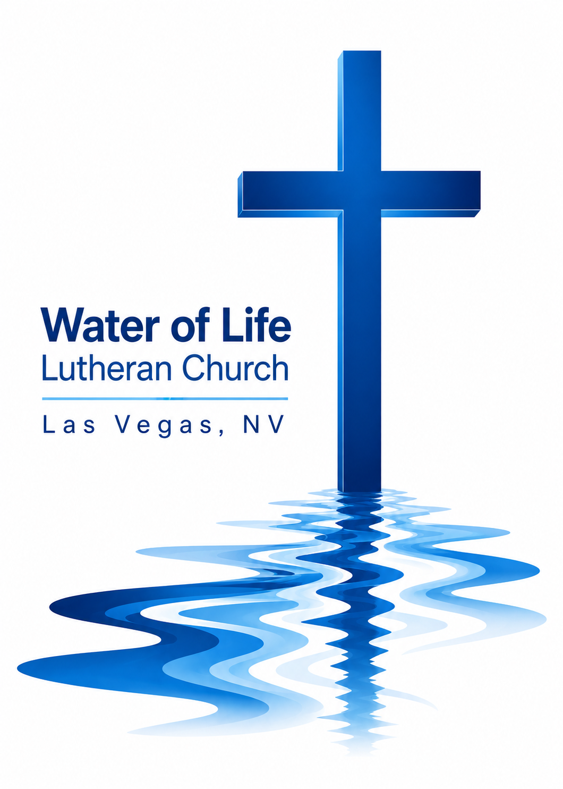

September 6, 2026
Fifteenth Sunday after Pentecost

WELCOME TO WORSHIP
Welcome and thank you for joining us for worship today! In our service we gather before our almighty and saving God to offer him our worship and praise. We also assemble to hear God’s holy and powerful word and celebrate his life-giving sacraments. Through these means, God strengthens our faith and walks us ever closer to our eternal home with him.

The order of service we follow is printed out in this worship folder. You’ll notice that the service is a dialogue between God and us, his people. The pastor speaks to God along with the congregation and also speaks the Word of God to the people.

Please fill out Connect Card. Place it in the plate when the offering is collected.
Holy Communion
If you are a guest with us today, please see page 12 in today’s worship folder
(the Worship Notes) for information about our practice of Member Communion.

Pastor David Bitter
Email: pastor@wateroflifelasvegas.org
Office phone number: (702) 253-7087
Cell phone Number: (414) 477-2321

Stacy Bitter – WoL Preschool Director
Email: director@wateroflifeschool.org
Office phone number: (702) 253-7020

Church Website: wateroflifelasvegas.org

Church Facebook page: Water of Life Lutheran Church Las Vegas


Scan code to give online

O Lord, My Rock and My Redeemer
O Lord, my rock and my Redeemer,
greatest treasure of my longing soul,
my God, like you there is no other,
true delight is found in you alone.
Your grace, a well too deep to fathom,
your love exceeds the heavens’ reach,
your truth, a fount of perfect wisdom,
my highest good and my unending need.

O Lord, my rock and my Redeemer,
strong defender of my weary heart,
my sword to fight the cruel deceiver,
and my shield against his hateful darts,
my song when enemies surround me,
my hope when tides of sorrow rise,
my joy when trials are abounding,
your faithfulness, my refuge in the night.

O Lord, my rock and my Redeemer,
gracious Savior of my ruined life,
my guilt and cross laid on your shoulders,
in my place you suffered, bled, and died.
You rose, the grave and death are conquered;
you broke my bonds of sin and shame.
O Lord, my rock and my Redeemer,
may all my days bring glory to your name.

Invocation

In the name of the Father and of the Son and of the Holy Spirit.
Amen.
Confession
Blessed are they whose transgressions are forgiven, whose sins are covered.
Blessed are they whose sin the Lord does not count against them.
Let us confess our sins to the Lord.
Almighty and merciful Father,
we have strayed from your ways like lost sheep.
We have followed what we have devised and desired in our hearts.
We have offended you and sinned against your holy law.
We have done those things that we should not have done,
and we have not done those things that we should have done.
Have mercy on us, Lord!
Spare us, forgive us, and restore us,
according to your promises in Christ Jesus.

Silence for meditation and reflection

Absolution

God, our merciful Father, has forgiven all our sins. He sent his Son, Jesus Christ, to be our Redeemer and Savior. Jesus paid the penalty for our guilt by his death on the cross and freed us from death by his resurrection from the grave. We have peace with God now and forever.
Amen.
Prayer of the Day
Mercifully grant, O God, that your Holy Spirit may in all things direct and rule our hearts, for without your help we are unable to please you; through your Son, Jesus Christ our Lord, who lives and reigns with you and the Holy Spirit, one God, now and forever.
Amen.
First Reading Ezekiel 33:7-11
7“Son of man, I have made you a watchman for the people of Israel; so hear the word I speak and give them warning from me. 8When I say to the wicked, ‘You wicked person, you will surely die,’ and you do not speak out to dissuade them from their ways, that wicked person will die for their sin, and I will hold you accountable for their blood. 9But if you do warn the wicked person to turn from their ways and they do not do so, they will die for their sin, though you yourself will be saved.
10“Son of man, say to the Israelites, ‘This is what you are saying: “Our offenses and sins weigh us down, and we are wasting away because of them. How then can we live?” ’ 11Say to them, ‘As surely as I live, declares the Sovereign Lord, I take no pleasure in the death of the wicked, but rather that they turn from their ways and live. Turn! Turn from your evil ways! Why will you die, people of Israel?’

The Word of the Lord.
Thanks be to God.

Second Reading Galatians 2:11-16
11When Cephas came to Antioch, I opposed him to his face, because he stood condemned. 12For before certain men came from James, he used to eat with the Gentiles. But when they arrived, he began to draw back and separate himself from the Gentiles because he was afraid of those who belonged to the circumcision group. 13The other Jews joined him in his hypocrisy, so that by their hypocrisy even Barnabas was led astray.
14When I saw that they were not acting in line with the truth of the gospel, I said to Cephas in front of them all, “You are a Jew, yet you live like a Gentile and not like a Jew. How is it, then, that you force Gentiles to follow Jewish customs?
15“We who are Jews by birth and not sinful Gentiles 16know that a person is not justified by the works of the law, but by faith in Jesus Christ. So we, too, have put our faith in Christ Jesus that we may be justified by faith in Christ and not by the works of the law, because by the works of the law no one will be justified.

The Word of the Lord.
Thanks be to God.

Gospel Acclamation Luke 12:34
Alleluia! Where your treasure is, there your heart will be also. Alleluia!
Gospel Matthew 18:15-20
15“If your brother or sister sins, go and point out their fault, just between the two of you. If they listen to you, you have won them over. 16But if they will not listen, take one or two others along, so that ‘every matter may be established by the testimony of two or three witnesses.’ 17If they still refuse to listen, tell it to the church; and if they refuse to listen even to the church, treat them as you would a pagan or a tax collector.
18“Truly I tell you, whatever you bind on earth will be bound in heaven, and whatever you loose on earth will be loosed in heaven.
19“Again, truly I tell you that if two of you on earth agree about anything they ask for, it will be done for them by my Father in heaven. 20For where two or three gather in my name, there am I with them.”

The Gospel of the Lord.
Praise be to you, O Christ!

Nicene Creed
We believe in one God, the Father, the Almighty,
maker of heaven and earth,
of all that is,
seen and unseen.

We believe in one Lord, Jesus Christ, the only Son of God,
eternally begotten of the Father,
God from God, Light from Light, true God from true God,
begotten, not made,
of one being with the Father.
Through him all things were made.
For us and for our salvation, he came down from heaven,
was incarnate of the Holy Spirit and the Virgin Mary,
and became truly human.
For our sake he was crucified under Pontius Pilate.
He suffered death and was buried.
On the third day he rose again in accordance with the Scriptures.
He ascended into heaven
and is seated at the right hand of the Father.
He will come again in glory to judge the living and the dead,
and his kingdom will have no end.

We believe in the Holy Spirit,
the Lord, the giver of life,
who proceeds from the Father and the Son,
who in unity with the Father and the Son
is worshiped and glorified,
who has spoken through the prophets.
We believe in one holy Christian and apostolic Church.
We acknowledge one baptism for the forgiveness of sins.
We look for the resurrection of the dead
and the life of the world to come. Amen.

Come, Behold the Wondrous Mystery
Come, behold the wondrous myst’ry,
in the dawning of the King,
he the theme of heaven’s praises,
robed in frail humanity.
In our longing, in our darkness,
now the light of life has come.
Look to Christ, who condescended,
took on flesh to ransom us.

Come, behold the wondrous myst’ry,
he the perfect Son of Man;
in his living, in his suff’ring
never trace nor stain of sin.
See the true and better Adam,
come to save the hellbound man.
Christ the great and sure fulfillment
of the law; in him we stand.

Come, behold the wondrous myst’ry,
Christ the Lord upon the tree;
in the stead of ruined sinners
hangs the Lamb in victory.
See the price of our redemption,
see the Father’s plan unfold,
bringing many sons to glory,
grace unmeasured, love untold.

Come, behold the wondrous myst’ry,
slain by death the God of life;
but no grave could e’er restrain him;
praise the Lord; he is alive!
What a foretaste of deliv’rance;
how unwavering our hope.
Christ in power resurrected
as will we be when he comes.

Sermon

Prayer of the Church
Loving God and Lord, you created the universe that surrounds us and the globe on which we live. You control all things through your Son, who sits at your right hand in glory.
Comfort us with the promise of your eternal presence.

Give your Word power as it works in our hearts and minds. Clear away our confusion, and demolish our doubts. Send your Spirit to strengthen both our confidence in your promises and our desire to live according to your will.
Take away our love of sinning and restore us each day by your grace.

The signs of the times warn us that the end of time is near. Protect us from scoffers who sneer at your truth. Spare us and Christians around the world from all forms of hate and persecution.
Give us courage to carry the cross with patience and joy.

Instill in the hearts of our children a desire to follow you as they prepare for future days. Help them distinguish between what is passing and what is eternal, between instant thrills and lasting joy. Encourage more young people to prepare for service in the public ministry of the gospel.
Mold us and move us to be good examples for our youth.

Hold in your care, Lord, those who are experiencing physical or emotional pain and all who are afflicted by disease or facing death. Pour out your compassion on the grieving and comfort the mourners who miss someone they loved.
Move us to pray for these brothers and sisters and to help when we can.

Hear us, Lord, as we pray in silence.

Silent prayer

Whether we pray together or alone, you have promised to hear and answer us. Give us patience to accept your blessings in whatever way you send them. In your love and wisdom, prepare us for the day when you will take us to be with you forever.
Hear us for Jesus’ sake. Amen.

Offering

Please place your connect card in the offering plate at this time.

Forgot your checkbook and don’t have cash but would still
like to give a gift
to help spread God’s Word?

Scan the QR code and you’ll be able to securely set up
anything you’d like to give in a number of different ways.

Or find the “give” button on the upper right side of our
website.
www.wateroflifelasvegas.org

The Sacrament
Preface

The Lord be with you.
And also with you.

Lift up your hearts.
We lift them up to the Lord.

Let us give thanks to the Lord our God.
It is right to give him thanks and praise.

It is truly good and right that we should at all times and in all places give you thanks, O Lord, holy Father, almighty and everlasting God, through Jesus Christ our Lord, who promised that wherever two or three come together in his name, there he is with them to shepherd his flock until he comes again in glory.
Prayer of Thanksgiving
Blessed are you, Lord God, eternal King and gracious Father. In love you made us the crown of your creation. In mercy you planned our salvation. In grace you sent your Son to redeem us from sin.
We remember and give you thanks that your eternal Son, Jesus Christ, became flesh and made his dwelling among us, that he willingly placed himself under law to redeem those under law, that he humbled himself by becoming obedient to death on a cross, that he has destroyed death and has brought life and immortality to light through the gospel.
Bless us as we receive your Son’s body and blood in this Sacrament. Forgive our sins, increase our faith, strengthen our fellowship, and deepen our longing for the day when Christ will welcome us to his eternal feast. Praise and thanks and honor and glory be to you, O God our Father, and to your Son and to the Holy Spirit, one God, now and forever.
Amen.

Lord’s Prayer

Our Father, who art in heaven,
hallowed be thy name,
thy kingdom come, thy will be done
on earth as it is in heaven.
Give us this day our daily bread;
and forgive us our trespasses,
as we forgive those
who trespass against us;
and lead us not into temptation,
but deliver us from evil.
For thine is the kingdom and the power and the
glory forever and ever. Amen.


Why We Practice Membership Communion:

The Lord’s Supper is a communion with Christ and a confession of shared faith. Therefore, Water of Life practices Member Communion. Confirmed members of WELS congregations are invited to receive the Sacrament. If you are not a WELS member and wish to receive Communion, please speak with the pastor after worship or at another time. We look forward to sharing with you God’s teaching about this Sacrament.

Words of Institution
Our Lord Jesus Christ, on the night he was betrayed, took bread; and when he had given thanks, he broke it and gave it to his disciples, saying, “Take and eat; this is my body, which is given for you. Do this in remembrance of me.”

Then he took the cup, gave thanks, and gave it to them, saying, “Drink from it, all of you; this is my blood of the new covenant, which is poured out for you for the forgiveness of sins. Do this, whenever you drink it, in remembrance of me.”

The peace of the Lord be with you always.
Amen.

Distribution

Give thanks to the Lord, for he is good;
his mercy endures forever.

Whenever we eat this bread and drink this cup,
we proclaim the Lord’s death until he comes.

O God the Father, source of all goodness, in your loving-kindness you sent your Son to share our humanity. We thank you that through him you have given us pardon and peace in this Sacrament. We also pray that you will not forsake us but will rule our hearts and minds by your Holy Spirit so that we willingly serve you day after day; through Jesus Christ our Lord, who lives and reigns with you and the Holy Spirit, one God, now and forever. Amen.
Blessing
Brothers and sisters go in peace. Live in harmony with one another and serve the Lord with gladness.
The Lord bless you and keep you.
The Lord make his face shine on you and be gracious to you.
The Lord look on you with favor and give you peace.
Amen.
Go, My Children, with My Blessing
Go, my children, with my blessing, never alone.
Waking, sleeping, I am with you; you are my own.
In my love’s baptismal river I have made you mine forever.
Go, my children, with my blessing, you are my own.

Go, my children, sins forgiven, at peace and pure.
Here you learned how much I love you, what I can cure.
Here you heard my dear Son’s story; here you touched him, saw his glory.
Go, my children, sins forgiven, at peace and pure.

Go, my children, fed and nourished, closer to me;
grow in love and love by serving, joyful and free.
Here my Spirit’s power filled you; here his tender comfort stilled you.
Go, my children, fed and nourished, joyful and free.

I the Lord will bless and keep and give you peace;
I the Lord will smile upon you and give you peace; I the Lord will be your Father, Savior, Comforter, and Brother.
Go, my children; I will keep you and give you peace.

Announcements

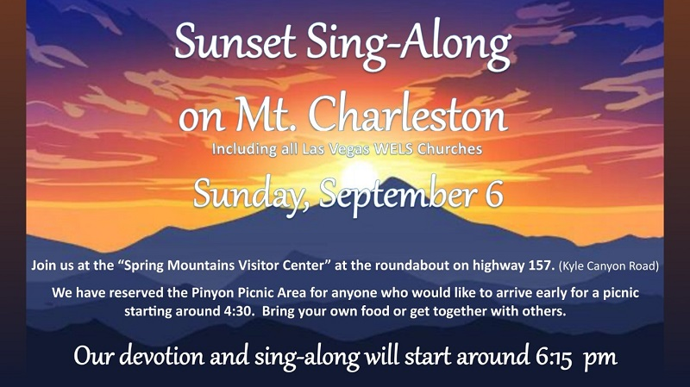

*****************************************************
Midweek Bible Study this week
Wednesday, September 9 , 7:00 PM
4608 Wonderful St. (Pastor and Stacy’s house)
****************************************************** Thank offerings given on August 30, 2026, in total, were $ 1,422.50
If you would like to set up online offerings please visit
secure.myvanco.com/LZ24S/home
This is the secure site to sign up for offerings made to Water of Life.
Offering envelopes are available.
If you would like a box, please see Jennifer Santos.
Thank you for supporting the ministry work at Water of Life.

