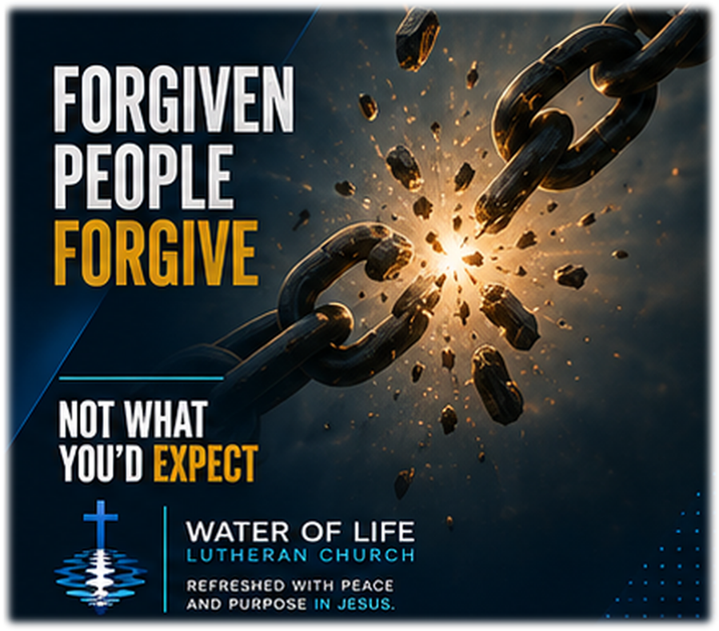

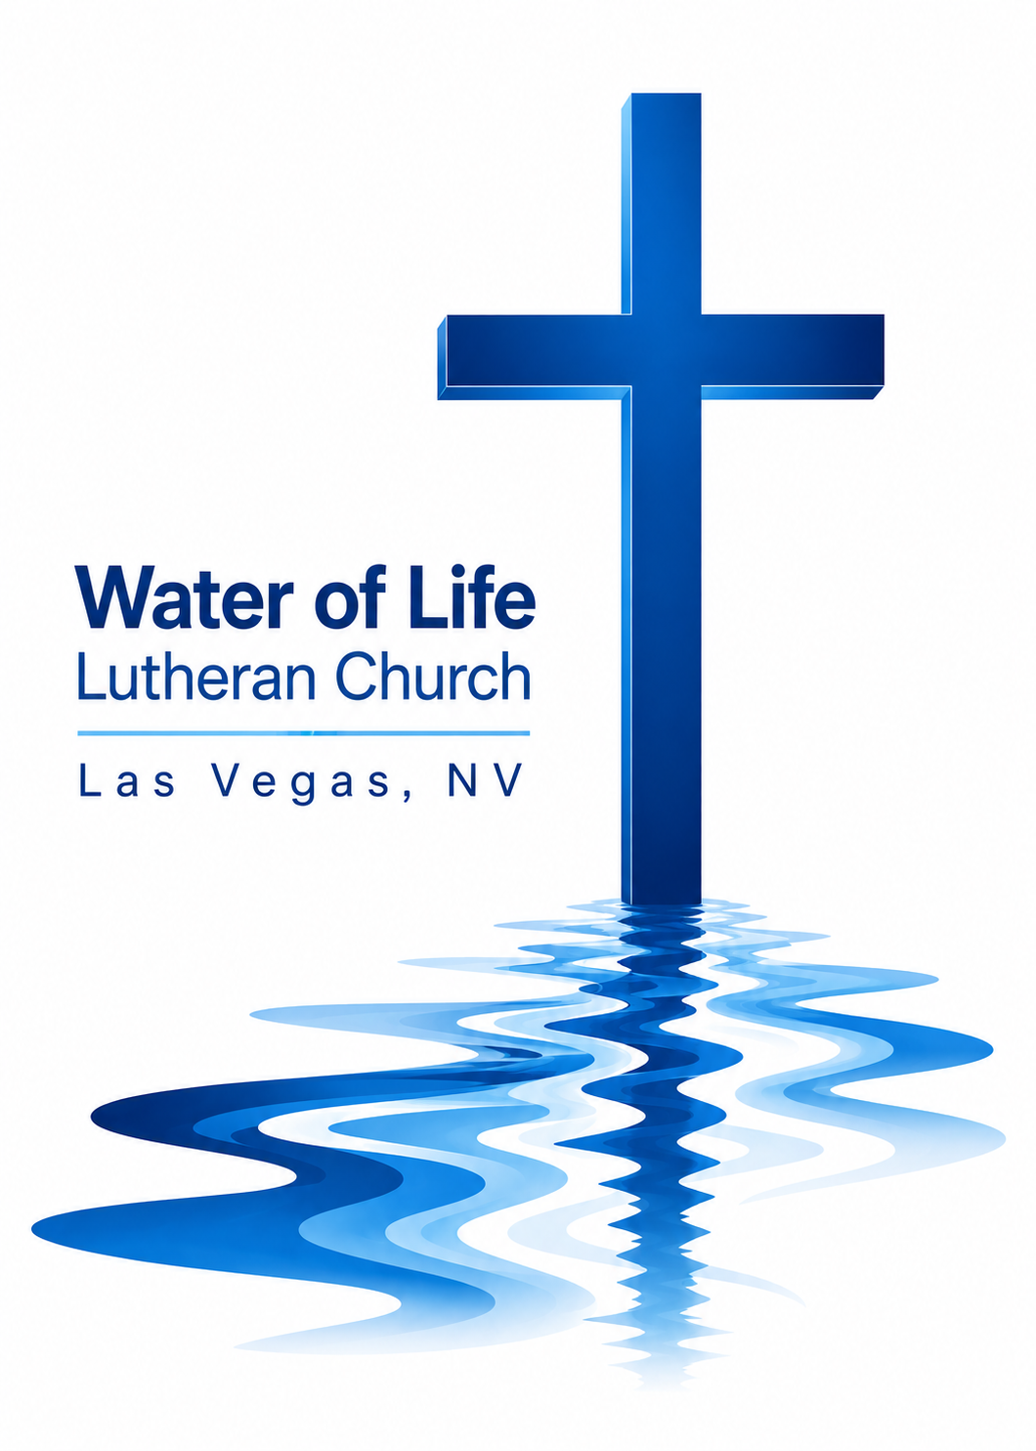
September 13, 2026
Sixteenth Sunday after Pentecost

WELCOME TO WORSHIP
Welcome and thank you for joining us for worship today! In our service we gather before our almighty and saving God to offer him our worship and praise. We also assemble to hear God’s holy and powerful word and celebrate his life-giving sacraments. Through these means, God strengthens our faith and walks us ever closer to our eternal home with him.

The order of service we follow is printed out in this worship folder. You’ll notice that the service is a dialogue between God and us, his people. The pastor speaks to God along with the congregation and also speaks the Word of God to the people.

Please fill out Connect Card. Place it in the plate when the offering is collected.

Pastor David Bitter
Email: pastor@wateroflifelasvegas.org
Office phone number: (702) 253-7087
Cell phone Number: (414) 477-2321

Stacy Bitter – WoL Preschool Director
Email: director@wateroflifeschool.org
Office phone number: (702) 253-7020

Church Website: wateroflifelasvegas.org

Church Facebook page: Water of Life Lutheran Church Las Vegas


Scan code to give online

Opening Hymn: We Praise You, O God, Our Redeemer

We praise you, O God, our Redeemer, Creator;
in grateful devotion our tribute we bring.
We lay it before you, we kneel and adore you;
we bless your holy name, glad praises we sing.

We worship you, God of our fathers, we bless you;
through trial and tempest our guide you have been.
When perils o’ertake us, you will not forsake us,
and with your help, O Lord, our battles we win.

With voices united our praises we offer
and gladly our songs of thanksgiving we raise.
With you, Lord, beside us, your strong arm will guide us;
to you, our great Redeemer, forever be praise!

Invocation

In the name of the Father and of the Son ✝ and of the Holy Spirit.
Amen.

Opening Sentences

The LORD is compassionate and gracious, slow to anger, abounding in love. He does not treat us as our sins deserve or repay us according to our iniquities.

As far as the east is from the west, so far has he removed our transgressions from us. (Psalm 103:8,10,12)

Confession of Sins

Our gracious God has forgiven us more than we can measure. Yet forgiveness does not come naturally to us. We defend ourselves, hold onto hurts, remember offenses, and struggle to show others the mercy we ourselves have received.
Therefore, let us confess our sins before our merciful Father.

Merciful Father, I confess that I have sinned against you in my thoughts, words, and actions. I have not loved you with my whole heart, and I have not loved my neighbor as myself. I have held grudges, kept records of wrongs, and been slow to forgive. Forgive me for the sake of Jesus Christ. Have mercy on me, renew me, and teach me to forgive as I have been forgiven.

Silence for meditation and reflection

Absolution

Hear the good news. God does not treat us as our sins deserve. Jesus took our enormous debt of sin upon himself and paid it completely at the cross. In Christ, your guilt is gone. Your debt has been canceled. Your sins are forgiven.
Therefore, as a called servant of Christ, and by his authority, I forgive you all your sins in the name of the Father and of the Son ✝ and of the Holy Spirit.
Amen.

Prayer of the Day

Almighty and merciful God, you have forgiven us a debt we could never repay. Fill our hearts with the mercy of Christ, that we may gladly forgive those who sin against us and reflect your grace in our lives; through your Son, Jesus Christ our Lord, who lives and reigns with you and the Holy Spirit, one God, now and forever.
Amen.

The Word

First Reading Genesis 50:15–21

15When Joseph’s brothers saw that their father was dead, they said, “What if Joseph holds a grudge against us and pays us back for all the wrongs we did to him?” 16So they sent word to Joseph, saying, “Your father left these instructions before he died: 17‘This is what you are to say to Joseph: I ask you to forgive your brothers the sins and the wrongs they committed in treating you so badly.’ Now please forgive the sins of the servants of the God of your father.” When their message came to him, Joseph wept.
18His brothers then came and threw themselves down before him. “We are your slaves,” they said.
19But Joseph said to them, “Don’t be afraid. Am I in the place of God? 20You intended to harm me, but God intended it for good to accomplish what is now being done, the saving of many lives. 21So then, don’t be afraid. I will provide for you and your children.” And he reassured them and spoke kindly to them.

The Word of the Lord.
Thanks be to God.

Second Reading Ephesians 4:29—5:2

29Do not let any unwholesome talk come out of your mouths, but only what is helpful for building others up according to their needs, that it may benefit those who listen. 30And do not grieve the Holy Spirit of God, with whom you were sealed for the day of redemption. 31Get rid of all bitterness, rage and anger, brawling and slander, along with every form of malice. 32Be kind and compassionate to one another, forgiving each other, just as in Christ God forgave you.
1Follow God’s example, therefore, as dearly loved children 2and walk in the way of love, just as Christ loved us and gave himself up for us as a fragrant offering and sacrifice to God.

The Word of the Lord.
Thanks be to God.

Gospel Acclamation Colossians 3:13

Alleluia. Bear with each other and forgive one another. Forgive as the Lord forgave you. Alleluia.

Gospel Matthew 18:21–35

21Then Peter came to Jesus and asked, “Lord, how many times shall I forgive my brother or sister who sins against me? Up to seven times?”
22Jesus answered, “I tell you, not seven times, but seventy-seven times.
23“Therefore, the kingdom of heaven is like a king who wanted to settle accounts with his servants. 24As he began the settlement, a man who owed him ten thousand bags of gold was brought to him. 25Since he was not able to pay, the master ordered that he and his wife and his children and all that he had be sold to repay the debt.
26“At this the servant fell on his knees before him. ‘Be patient with me,’ he begged, ‘and I will pay back everything.’ 27The servant’s master took pity on him, canceled the debt and let him go.
28“But when that servant went out, he found one of his fellow servants who owed him a hundred silver coins. He grabbed him and began to choke him. ‘Pay back what you owe me!’ he demanded.
29“His fellow servant fell to his knees and begged him, ‘Be patient with me, and I will pay it back.’
30“But he refused. Instead, he went off and had the man thrown into prison until he could pay the debt. 31When the other servants saw what had happened, they were outraged and went and told their master everything that had happened.
32“Then the master called the servant in. ‘You wicked servant,’ he said, ‘I canceled all that debt of yours because you begged me to. 33Shouldn’t you have had mercy on your fellow servant just as I had on you?’ 34In anger his master handed him over to the jailers to be tortured, until he should pay back all he owed.
35“This is how my heavenly Father will treat each of you unless you forgive your brother or sister from your heart.”

The Gospel of the Lord.
Praise be to you, O Christ!

Apostles’ Creed

I believe in God, the Father Almighty, maker of heaven and earth.
I believe in Jesus Christ, his only Son, our Lord, who was conceived by the Holy Spirit, born of the Virgin Mary, suffered under Pontius Pilate, was crucified, died, and was buried.
He descended into hell. The third day he rose again from the dead.
He ascended into heaven and is seated at the right hand of God the Father Almighty. From there he will come to judge the living and the dead.
I believe in the Holy Spirit, the holy Christian Church, the communion of saints, the forgiveness of sins, the resurrection of the body, and the life everlasting. Amen.

Sermon Hymn: His Mercy Is More

What love could remember no wrongs we have done?
Omniscient, all-knowing, he counts not their sum;
thrown into a sea without bottom or shore,
our sins they are many, his mercy is more. (Refrain)

Refrain Praise the Lord! His mercy is more!
Stronger than darkness, new ev’ry morn;
our sins they are many, his mercy is more!

What patience would wait as we constantly roam,
what Father so tender is calling us home!
He welcomes the weakest, the vilest, the poor;
our sins they are many, his mercy is more. (Refrain)

What riches of kindness he lavished on us;
his blood was the payment, his life was the cost.
We stood ’neath a debt we could never afford;
our sins they are many, his mercy is more. (Refrain 3X)

Sermon

Offering
Our offerings are a joyful response to God’s grace and an opportunity to support the gospel ministry.
Please place your connect card in the offering plate at this time.

Forgot your checkbook and don’t have cash but would still
like to give a gift
to help spread God’s Word?

Scan the QR code and you’ll be able to securely set up
anything you’d like to give in a number of different ways.

Or find the “give” button on the upper right side of our
website.
www.wateroflifelasvegas.org

Prayer of the Church

Lord God, heavenly Father, you are compassionate and gracious, slow to anger and abounding in love. You do not treat us as our sins deserve. Through the life, death, and resurrection of your Son, you have canceled the debt we could never repay and removed our sins from us as far as the east is from the west.
Merciful Lord, teach us to forgive as you have forgiven us.

Gracious Father, preserve your holy Christian Church throughout the world. Bless pastors, teachers, missionaries, parents, and all who proclaim your Word. Keep the message of Christ’s full and free forgiveness at the center of the Church’s preaching and teaching. Through that gospel, bring sinners to repentance, strengthen faith, and comfort troubled consciences.
Merciful Lord, teach us to forgive as you have forgiven us.

Bless this congregation, our Sunday School, confirmation classes, and our preschool. Let every child, family, visitor, and member who comes through our doors hear clearly what you have done for sinners in Christ. Make us a congregation known not only for speaking about grace, but also for showing patience, compassion, kindness, and forgiveness to one another.
Merciful Lord, teach us to forgive as you have forgiven us.

Give us passion to share the story of your love with our family and friends. Overcome unbelief, and open the hearts of people everywhere to believe the good news that Jesus has forgiven their sins and opened the gates of heaven.
Merciful Lord, teach us to forgive as you have forgiven us.

We pray for those who are sick, grieving, lonely, anxious, weary, or burdened by the cares of this life. Give healing according to your will, strength for each day, and the assurance that in Christ nothing can separate them from your love.
Lift the eyes of the distressed to your love in Christ.
Hear us, Lord, as we pray in silence.

Silent prayer
Gracious God, you govern and direct all things and you love all people. Hear our prayers, spoken and silent, and answer them in your wisdom and grace. In Jesus’ name we pray. Amen.
Lord’s Prayer
Our Father, who art in heaven, hallowed be thy name,
thy kingdom come, thy will be done on earth as it is in heaven.
Give us this day our daily bread; and forgive us our trespasses,
as we forgive those who trespass against us;
and lead us not into temptation, but deliver us from evil.
For thine is the kingdom and the power and the glory forever and ever. Amen.

Blessing

Brothers and sisters go in peace. Live in harmony with one another and serve the Lord with gladness.
The Lord bless you and keep you.
The Lord make his face shine on you and be gracious to you.
The Lord look on you with favor and give you peace.
Amen.

Closing Hymn: Love in Christ Is Strong and Living

Love in Christ is strong and living,
binding faithful hearts in one;
love in Christ is true and giving,
may his will in us be done.

Love is patient and forbearing,
clothed in Christ’s humility,
gentle, selfless, kind, and caring,
reaching out in charity.

Love in Christ abides forever,
fainting not when ills attend;
love, forgiving and forgiven,
shall endure until life’s end.

Announcements

Midweek Bible Study

Wednesday at 7:00 PM 4608 Wonderful St.

Confirmation Class starts Today at 11:15am

Thank offerings given on September 6, 2026, in total, were $1,742.50
If you would like to set up online offerings please visit
secure.myvanco.com/LZ24S/home
This is the secure site to sign up for offerings made to Water of Life.
Offering envelopes are available.
If you would like a box, please see Jennifer Santos.
Thank you for supporting the ministry work at Water of Life.

