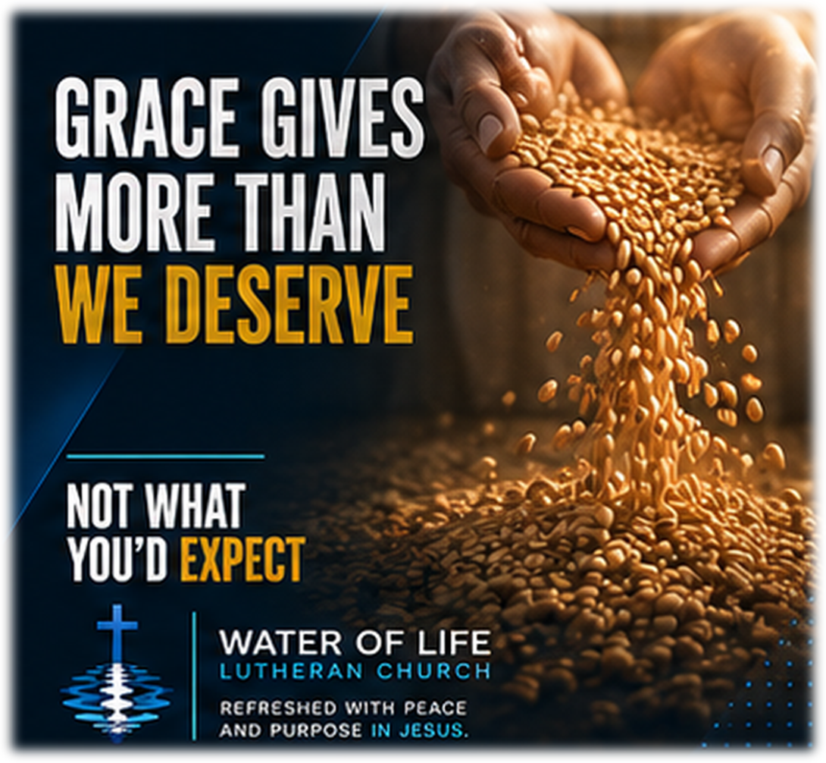

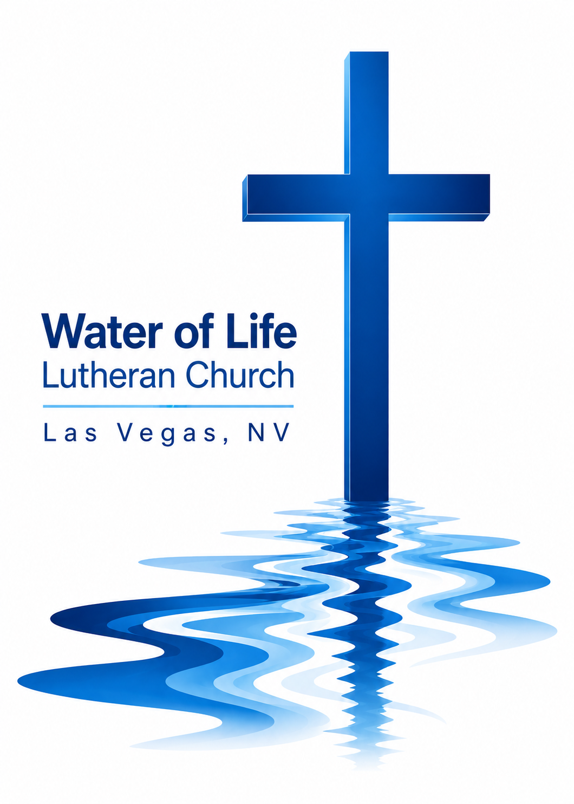

September 20, 2026
Seventeenth Sunday after Pentecost

WELCOME TO WORSHIP
Welcome and thank you for joining us for worship today! In our service we gather before our almighty and saving God to offer him our worship and praise. We also assemble to hear God’s holy and powerful word and celebrate his life-giving sacraments. Through these means, God strengthens our faith and walks us ever closer to our eternal home with him.

The order of service we follow is printed out in this worship folder. You’ll notice that the service is a dialogue between God and us, his people. The pastor speaks to God along with the congregation and also speaks the Word of God to the people.

Please fill out Connect Card. Place it in the plate when the offering is collected.
Holy Communion
If you are a guest with us today, please see page 11 in today’s worship folder
(the Worship Notes) for information about our practice of Member Communion.

Pastor David Bitter
Email: pastor@wateroflifelasvegas.org
Office phone number: (702) 253-7087
Cell phone Number: (414) 477-2321

Stacy Bitter – WoL Preschool Director
Email: director@wateroflifeschool.org
Office phone number: (702) 253-7020

Church Website: wateroflifelasvegas.org

Church Facebook page: Water of Life Lutheran Church Las Vegas


Scan code to give online

Not To Us
Not to us, oh Lord, not to us, oh Lord
But unto Your name be the glory
From the dawn of time to its setting sun
The name of the Lord shall be praised
One song will ring through the ages
One throne will ever remain
This world will pass and its glories fade
One name forever shall be praised
While the nations rage trusting idols vain
Our God stands alone in the heavens
Robed in majesty hail the highest King
The name of the Lord shall be praised
One song will ring through the ages
One throne will ever remain
This world will pass and its glories fade
One name forever shall be praised
One name forever shall be praised
May Your face be set, may Your blessing rest
Upon us Your people beloved
Mark us by Your grace that the world would say
The name of the Lord shall be praised
One song will ring through the ages
One throne will ever remain
This world will pass and its glories fade
One name forever shall be praised
One song will ring through the ages
One throne will ever remain
This world will pass and its glories fade
One name forever shall be praised
One name forever shall be praised
One name forever shall be praised

Invocation

In the name of the Father and of the Son and of the Holy Spirit.
Amen.

Opening Sentences

We live in a world that keeps score. We expect people to get what they have earned and receive what they deserve. We can even begin to think that way about our relationship with God. But God’s grace turns our attention away from what we have done and toward what he has done for us.

Not to us, LORD, not to us but to your name be the glory, because of your love and faithfulness. (Psalm 115:1)

We have nothing to boast about before God. Everything we have from him is a gift of his grace.

Trust in the LORD—he is your and shield. (Psalm 115:9)

We trust the Lord not because we have earned his favor, but because he is faithful to his promises.

The LORD remembers us and will bless us. (Psalm 115:12)

Confession
When we compare ourselves with others, it is easy to think that we deserve more and they deserve less and we can resent God’s mercy when it is shown to people we believe do not deserve it.
But before God, none of us can claim to have earned his favor. Therefore, let us confess our sins and ask him for mercy.

Gracious Father, I confess that I have sinned against you in my thoughts, words, and actions.
I have compared myself with others and failed to see the seriousness of my own sin.
I have acted as though your blessings were something I earned rather than gifts of your grace.
I have even resented the favor you have shown to others. For this I deserve your punishment, not your favor. For the sake of Jesus Christ, have mercy on me. Forgive my sins and teach me to rejoice in your amazing grace.

Silence for meditation and reflection
Declaration of Grace
God does not give us what our sins deserve. Instead, he gave his Son what our sins deserved. Through his perfect life, innocent death, and victorious resurrection, God gives us what we could never earn: forgiveness, peace, and eternal life.
Therefore, as a called servant of Christ, and by his authority, I forgive you all your sins in the name of the Father and of the Son ✝ and of the Holy Spirit.
Amen.

The Word
Prayer of the Day
Gracious Father, everything we have is a gift of your undeserved love. In Jesus Christ you have given us forgiveness, life, and salvation. Keep us from comparing ourselves with others, and fix our eyes on your generosity, that we may rejoice in your grace to us and to every sinner; through Jesus Christ, your Son, our Lord.
Amen.

First Reading Jonah 3:10—4:11
10When God saw what they did and how they turned from their evil ways, he relented and did not bring on them the destruction he had threatened.
1But to Jonah this seemed very wrong, and he became angry. 2He prayed to the Lord, “Isn’t this what I said, Lord, when I was still at home? That is what I tried to forestall by fleeing to Tarshish. I knew that you are a gracious and compassionate God, slow to anger and abounding in love, a God who relents from sending calamity. 3Now, Lord, take away my life, for it is better for me to die than to live.”
4But the Lord replied, “Is it right for you to be angry?”
5Jonah had gone out and sat down at a place east of the city. There he made himself a shelter, sat in its shade and waited to see what would happen to the city. 6Then the Lord God provided a leafy plant and made it grow up over Jonah to give shade for his head to ease his discomfort, and Jonah was very happy about the plant. 7But at dawn the next day God provided a worm, which chewed the plant so that it withered. 8When the sun rose, God provided a scorching east wind, and the sun blazed on Jonah’s head so that he grew faint. He wanted to die, and said, “It would be better for me to die than to live.”
9But God said to Jonah, “Is it right for you to be angry about the plant?”
“It is,” he said. “And I’m so angry I wish I were dead.”
10But the Lord said, “You have been concerned about this plant, though you did not tend it or make it grow. It sprang up overnight and died overnight. 11And should I not have concern for the great city of Nineveh, in which there are more than a hundred and twenty thousand people who cannot tell their right hand from their left—and also many animals?”

The Word of the Lord.
Thanks be to God.

Second Reading Ephesians 2:8–10
8For it is by grace you have been saved, through faith—and this is not from yourselves, it is the gift of God— 9not by works, so that no one can boast. 10For we are God’s handiwork, created in Christ Jesus to do good works, which God prepared in advance for us to do.

The Word of the Lord.
Thanks be to God.

Gospel Acclamation Ephesians 2:8
Alleluia!
For it is by grace you have been saved, through faith—
and this is not from yourselves, it is the gift of God.
Alleluia!

Gospel Matthew 20:1–16
1“For the kingdom of heaven is like a landowner who went out early in the morning to hire workers for his vineyard. 2He agreed to pay them a denarius for the day and sent them into his vineyard.
3“About nine in the morning he went out and saw others standing in the marketplace doing nothing. 4He told them, ‘You also go and work in my vineyard, and I will pay you whatever is right.’ 5So they went.
“He went out again about noon and about three in the afternoon and did the same thing. 6About five in the afternoon he went out and found still others standing around. He asked them, ‘Why have you been standing here all day long doing nothing?’
7“ ‘Because no one has hired us,’ they answered.
“He said to them, ‘You also go and work in my vineyard.’
8“When evening came, the owner of the vineyard said to his foreman, ‘Call the workers and pay them their wages, beginning with the last ones hired and going on to the first.’
9“The workers who were hired about five in the afternoon came and each received a denarius. 10So when those came who were hired first, they expected to receive more. But each one of them also received a denarius. 11When they received it, they began to grumble against the landowner. 12‘These who were hired last worked only one hour,’ they said, ‘and you have made them equal to us who have borne the burden of the work and the heat of the day.’
13“But he answered one of them, ‘I am not being unfair to you, friend. Didn’t you agree to work for a denarius? 14Take your pay and go. I want to give the one who was hired last the same as I gave you. 15Don’t I have the right to do what I want with my own money? Or are you envious because I am generous?’
16“So the last will be first, and the first will be last.”

The Gospel of the Lord.
Praise be to you, O Christ!
Nicene Creed
We believe in one God, the Father, the Almighty,
maker of heaven and earth, of all that is, seen and unseen.

We believe in one Lord, Jesus Christ, the only Son of God,
eternally begotten of the Father, God from God, Light from Light, true
God from true God, begotten, not made, of one being with the Father.
Through him all things were made.
For us and for our salvation, he came down from heaven, was incarnate
of the Holy Spirit and the Virgin Mary, and became truly human.
For our sake he was crucified under Pontius Pilate. He suffered death
and was buried.
On the third day he rose again in accordance with the Scriptures.
He ascended into heaven and is seated at the right hand of the Father.
He will come again in glory to judge the living and the dead, and his
kingdom will have no end.

We believe in the Holy Spirit, the Lord, the giver of life,
who proceeds from the Father and the Son, who in unity with the
Father and the Son is worshiped and glorified, who has spoken
through the prophets. We believe in one holy Christian and apostolic
Church. We acknowledge one baptism for the forgiveness of sins.
We look for the resurrection of the dead and the life of the world to
come. Amen.
Jesus Strong and Kind
Jesus said that if I thirst
I should come to Him
No one else can satisfy
I should come to Him

Jesus said if I am weak
I should come to Him
No one else can be my strength
I should come to Him

For the Lord is good and faithful
He will keep us day and night
We can always run to Jesus
Jesus, strong and kind

Jesus said that if I fear
I should come to Him
No one else can be my shield
I should come to Him

For the Lord is good and faithful
He will keep us day and night
We can always run to Jesus
Jesus, strong and kind

Jesus said if I am lost
He will come to me
And He showed me on that cross
He will come to me

For the Lord is good and faithful
He will keep us day and night
We can always run to Jesus
Jesus, strong and kind

For the Lord is good and faithful
He will keep us day and night
We can always run to Jesus
Jesus, strong and kind
Jesus, strong and kind
Sermon
Prayer of the Church
Loving God and Lord, you created the universe that surrounds us and the globe on which we live. You control all things through your Son, who sits at your right hand in glory.
Comfort us with the promise of your eternal presence.

Give your Word power as it works in our hearts and minds. Clear away our confusion, and demolish our doubts. Send your Spirit to strengthen both our confidence in your promises and our desire to live according to your will.
Take away our love of sinning, and restore us each day by your grace.

The signs of the times warn us that the end of time is near. Protect us from scoffers who sneer at your truth. Spare us and Christians around the world from all forms of hate and persecution.
Give us courage to carry the cross with patience and joy.

Instill in the hearts of our children a desire to follow you as they prepare for future days. Help them distinguish between what is passing and what is eternal, between instant thrills and lasting joy. Encourage more young people to prepare for service in the public ministry of the gospel.
Mold us and move us to be good examples for our youth.

Hold in your care, Lord, those who are experiencing physical or emotional pain and all who are afflicted by disease or facing death. [Especially bless . . . here name the person and the cause of the petition.] Pour out your compassion on the grieving, and comfort the mourners who miss someone they loved.
Move us to pray for these brothers and sisters and to help when we can.

Hear us, Lord, as we pray in silence.

Silent prayer

Whether we pray together or alone, you have promised to hear and answer us. Give us patience to accept your blessings in whatever way you send them. In your love and wisdom, prepare us for the day when you will take us to be with you forever.
Hear us for Jesus’ sake. Amen.

Offering
Our offerings are a joyful response to God’s grace and an opportunity to support the gospel ministry.
Please place your connect card in the offering plate at this time.

Forgot your checkbook and don’t have cash but would still
like to give a gift
to help spread God’s Word?

Scan the QR code and you’ll be able to securely set up
anything you’d like to give in a number of different ways.

Or find the “give” button on the upper right side of our
website.
www.wateroflifelasvegas.org

Why We Practice Membership Communion:

The Lord’s Supper is a communion with Christ and a
confession of shared faith. Therefore, Water of Life
practices Member Communion. Confirmed members of
WELS congregations are invited to receive the Sacrament.
If you are not a WELS member and wish to receive
Communion, please speak with the pastor after worship or
at another time. We look forward to sharing with you God’s
teaching about this Sacrament.

The Sacrament
Preface

The Lord be with you.
And also with you.

Lift up your hearts.
We lift them up to the Lord.

Let us give thanks to the Lord our God.
It is right to give him thanks and praise.

It is truly good and right that we should at all times and in all places give you thanks, O Lord, holy Father, almighty and everlasting God, through Jesus Christ our Lord, who promised that wherever two or three come together in his name, there he is with them to shepherd his flock until he comes again in glory.

Prayer of Thanksgiving
Blessed are you, Lord God, eternal King and gracious Father. In love you made us the crown of your creation. In mercy you planned our salvation. In grace you sent your Son to redeem us from sin.

We remember and give you thanks that your eternal Son, Jesus Christ, became flesh and made his dwelling among us, that he willingly placed himself under law to redeem those under law, that he humbled himself by becoming obedient to death on a cross, that he has destroyed death and has brought life and immortality to light through the gospel.

Bless us as we receive your Son’s body and blood in this Sacrament. Forgive our sins, increase our faith, strengthen our fellowship, and deepen our longing for the day when Christ will welcome us to his eternal feast. Praise and thanks and honor and glory be to you, O God our Father, and to your Son and to the Holy Spirit, one God, now and forever.
Amen.

Lord’s Prayer
Our Father, who art in heaven,
hallowed be thy name, thy kingdom come, thy will be done
on earth as it is in heaven. Give us this day our daily bread;
and forgive us our trespasses, as we forgive those
who trespass against us; and lead us not into temptation,
but deliver us from evil. For thine is the kingdom and the power and the
glory forever and ever. Amen.

Words of Institution

Our Lord Jesus Christ, on the night he was betrayed, took bread; and when he had given thanks, he broke it and gave it to his disciples, saying, “Take and eat; this is my body, which is given for you. Do this in remembrance of me.”

Then he took the cup, gave thanks, and gave it to them, saying, “Drink from it, all of you; this is my blood of the new covenant, which is poured out for you for the forgiveness of sins. Do this, whenever you drink it, in remembrance of me.”
The peace of the Lord be with you always.
Amen.
Distribution
Give thanks to the Lord, for he is good;
his mercy endures forever.

Whenever we eat this bread and drink this cup,
we proclaim the Lord’s death until he comes.

O God the Father, source of all goodness, in your loving-kindness you sent your Son to share our humanity. We thank you that through him you have given us pardon and peace in this Sacrament. We also pray that you will not forsake us but will rule our hearts and minds by your Holy Spirit so that we willingly serve you day after day; through Jesus Christ our Lord, who lives and reigns with you and the Holy Spirit, one God, now and forever.
Amen.

Blessing
Brothers and sisters go in peace. Live in harmony with one another and serve the Lord with gladness. The Lord bless you and keep you.
The Lord make his face shine on you and be gracious to you.
The Lord look on you with favor and give you peace.
Amen.
Amazing Grace
Amazing grace—how sweet the sound— that saved a wretch like me!
I once was lost but now am found, was blind but now I see.

The Lord has promised good to me, his Word my hope secures;
he will my shield and portion be as long as life endures.

Through many dangers, toils, and snares I have already come;
’tis grace has brought me safe thus far, and grace will lead me home.

When we’ve been there ten thousand years, bright shining as the sun,
we’ve no less days to sing God’s praise than when we’d first begun.

Announcements

Midweek Bible Study this week
Wednesday, September 23, 7:00 PM
4608 Wonderful St. (Pastor and Stacy’s house)
****************************************************** Thank offerings given on August 30, 2026, in total, were $ 1,990.50
If you would like to set up online offerings please visit
secure.myvanco.com/LZ24S/home
This is the secure site to sign up for offerings made to Water of Life.
Offering envelopes are available.
If you would like a box, please see Jennifer Santos.
Thank you for supporting the ministry work at Water of Life.

